

1000 Yarnell Pl, Oxnard CA 93033

GRANATELLI MOTOR SPORTS ™bILLET RACE Harness SLACK collars

Thank you for your purchase of the Granatelli Motor Sports Race Belt Residual Slack Retention Harness Collars. This Installation is very easy to perform if you follow the instructions and images below.

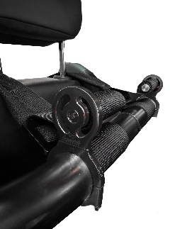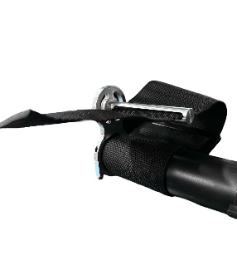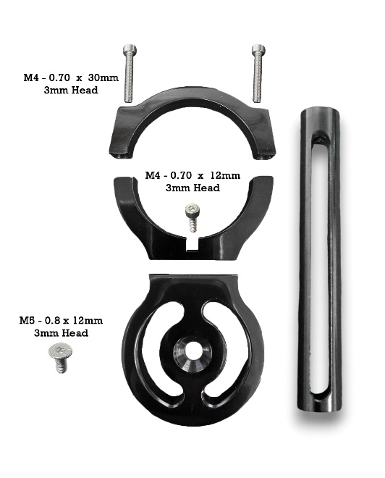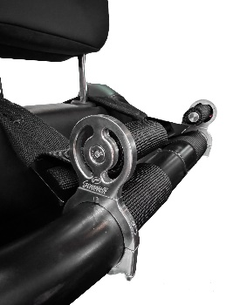

Image 1 Image 2 Product Image Image 3 Image 4
- Using a 3mm Allen Head, install (fasten) the main body to the upper collar using the supplied (1) M4-.070 x 12mm long cap screws. (See Product Image Above Center)
- Using a 3mm Allen Head, install (fasten) the slotted harness rod to the main body with the (1) M5-0.80 x 12mm tapered head screw. – Note: Do not tighten just yet.
- Using a 3mm Allen Head, mount your Granatelli Motor Sports Race Belt Residual Slack Harness Collar to your roll cage outward of the edge of the belt as shown above with the (2) M4-.070 x 30mm.
- Tighten the (2) M4-.070 x 30mm long screws with your 3mm Allen Head to a point where they are snug plus a ¼ turn. No need to over torque these screws.
- Insert the residual harness slack through the slot of the harness rod to a point where it just peaks through and roll your slack, counter clockwise until hand tight. Then tighten the screw from step 2 until snug. NOTE: You want to roll up your harness counter clockwise so if you pull on the slack it rotates the slotted rod clockwise, as if it were self-tightening.
Disclaimer: Your Granatelli Motor Sports Race Belt Residual Slack Harness Collars are not intended to be structural components. They should NEVER be used as your main harness mount or used to support any load. This is a cosmetically appealing part only.

